**Q2. Use Wireshark to capture and analyze DNS, TCP, UDP traffic and packet header, packet flow, options and flags.**

DNS:

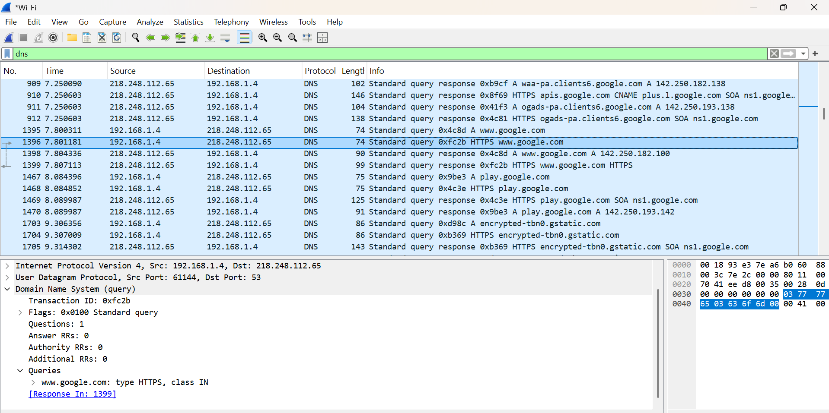

**tcp:**

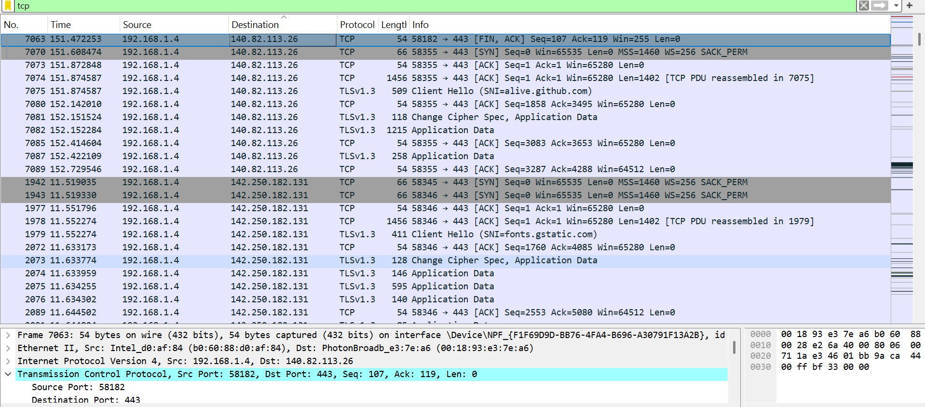

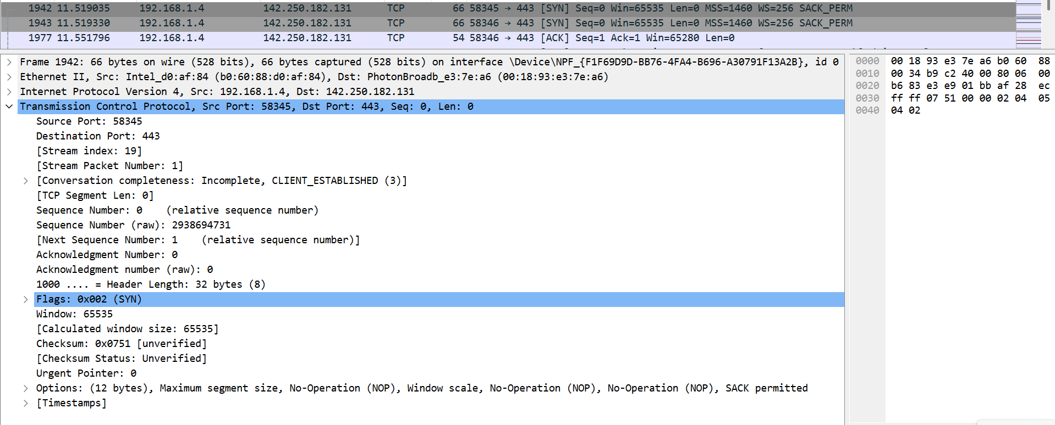

**Filters of tcp to filter ot only the handhaking signals:**

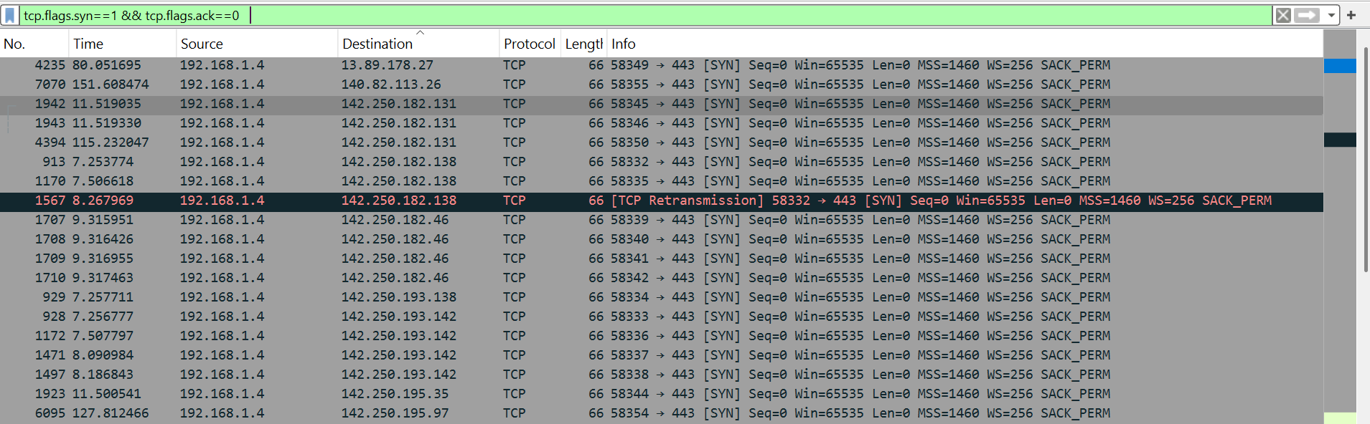

**UDP:**

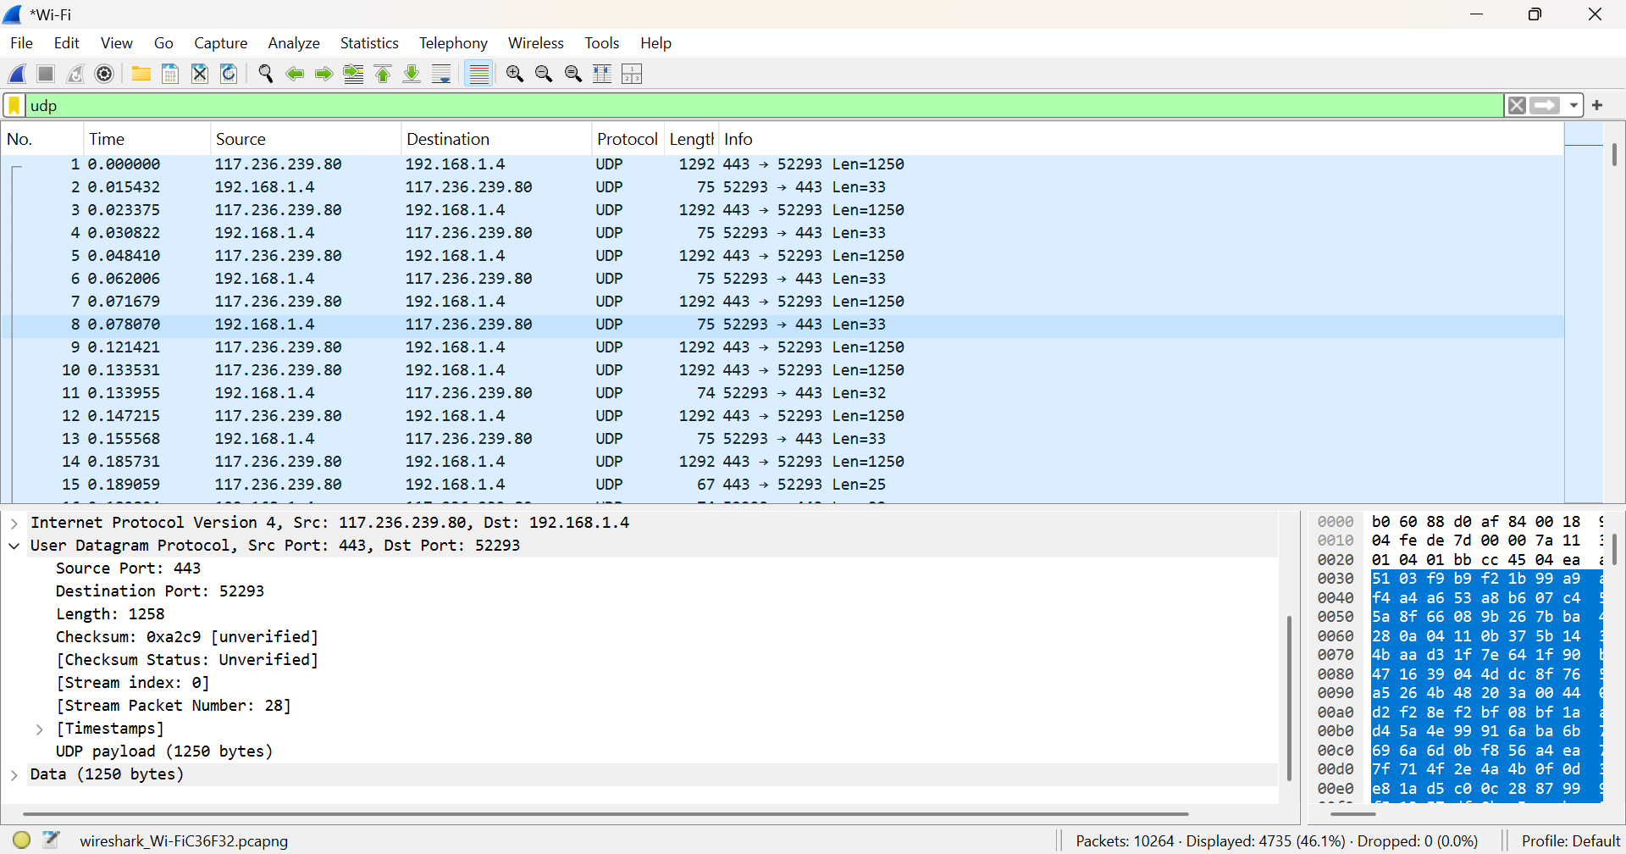

**Packet header(Ethernet and ip protocols)**

